**Deploy PHP web application using Kubernetes and automated deployment through jenkins**

**Step 1:** **Creating simple dockerfile**

* Create a Docker file with the below mentioned contents and place it in the root location of the project repository.

##**DockerFile**

#Pulling base php-apache image from dockerhub

**FROM php:7.0-apache**

#Run php commands to build and serve the application

**RUN apt-get update && \**

**apt-get clean**

# The PHP application code goes in php-App/

**COPY php-App /var/www/html/**

**Step 2: Creating Kubernetes yaml file**

* Create a Kubernetes yaml file (php-sample.yaml) with the following contents and place it in the root location of the project repository.

apiVersion: apps/v1

kind: Deployment

metadata:

name: php-App

labels:

app: php-App

spec:

selector:

matchLabels:

app: php-App

template:

metadata:

labels:

app: php-App

spec:

containers:

- image: ip_address_of_the_machine:5000/php-App:latest

name: php-sample

imagePullPolicy: Always

ports:

- containerPort: 80

---

apiVersion: v1

kind: Service

metadata:

name: php-App-svc

spec:

ports:

- name: "php-App"

targetPort: 80

port: 80

nodePort: 30270

protocol: TCP

selector:

app: php-App

type: NodePort

**Step 3: Jenkins Configuration**

* Creating Jenkins job
* Open the Jenkins URL and click on “New Item”

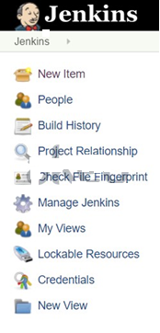

* Provide a name for the job and select freestyle job
* Provide the git repository URL and credentials for cloning the project. Don’t forget to specify the branch.

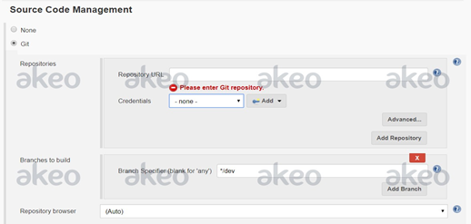

* Select “Execute Shell” from the add build step

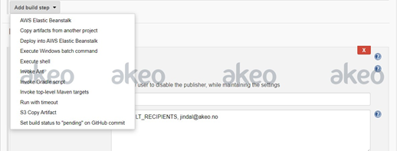

* Provide the steps as shown in the image below

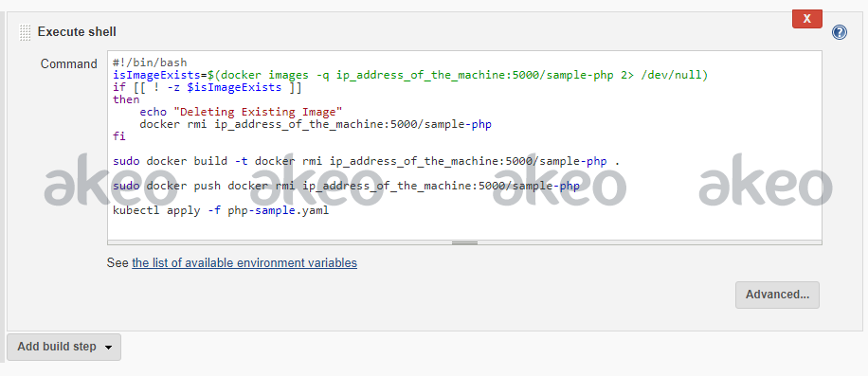

* Save the job and execute it
* This will create a docker image and push to the private Docker registry. Also, the kubectl apply command will configure the pod with php-App application running inside it. The purpose of pushing the Docker image to the Docker registry is that this image can be used on any other Ubuntu machine to run the application.
* Access the application on the url http://ip_address:30270